# 

Questionnaire Management System

CSE454 – Advanced Software Engineering

Team Members:

Abdallah Amir Monir

Ahmed Abed Haseeb

Ahmed Ehab Mohammed

Khaled Saeed Zahran

Mazen Ehab Fathy

*Under Supervision of:*

*Dr. Ahmed Badawy*

*Eng. Aya Ibrahim*

Table of Contents

Overview 3

Project Description 3

System Diagrams 4

Project Timeline Diagram 4

Use Case Diagram 5

Entity Relationship Diagram 6

Class Diagram 7

# Overview

*This documentation provides a comprehensive view of the* ***Questionnaire Management System (QMS)****, outlining the purpose, scope, and core components. The* ***QMS*** *is designed to streamline the creation, management, and analysis of questionnaires, offering a user-friendly platform for organizations to gather and analyze feedback efficiently. This system incorporates various modules, including* ***questionnaire creation****,* ***user management****,* ***response handling****,* ***analytics****, and* ***reporting****.*

# Project Description

**Questionnaire Management System (QMS)** is a web-based application specifically designed **for New Mansoura University** to facilitate the creation, management, and analysis of questionnaires. This system is **tailored for the university's administrative and research needs**, offering a streamlined solution for **gathering student feedback**, **conducting campus-wide surveys**, and **performing in-depth data analysis**.

The QMS provides an intuitive interface that allows administrators and educators to design customized questionnaires, distribute them to students and faculty, and monitor responses in real time. Built with scalability and security in mind, the system incorporates essential features such as user authentication, response management, data validation, error handling, and analytics, ensuring that data is both accessible and secure. Key features of the system include:

* **Questionnaire Builder:** A dynamic, drag-and-drop tool for creating questionnaires with various question types, including multiple-choice, short answers, rating scales, and more. This feature supports advanced capabilities, such as conditional logic, enabling customized question flows based on respondents’ answers.
* **User Management and Security**: Implements secure user authentication and authorization protocols to ensure that only authorized users have access to specific parts of the system. Role-based permissions differentiate between administrators, educators, and general respondents, maintaining privacy and data security.
* **Response Management**: A comprehensive module for managing incoming responses, with built-in validation and error handling to ensure the accuracy and integrity of collected data. The system supports data export in various formats, allowing for further analysis or archiving.
* **Data Analytics and Reporting**: An analytics engine that generates detailed reports and visualizations, providing administrators and educators with insights into response patterns and trends. Customizable reporting options allow users to tailor analytics to meet specific requirements for decision-making and research.
* **Feedback Collection and Continuous Improvement**: A feedback mechanism that enables respondents to provide feedback on both the questionnaires and the system itself, allowing for continuous improvement based on real user input.

The **Questionnaire Management System** is expected to enhance **New Mansoura University's** data collection and analysis processes, supporting data-driven decision-making across academic and administrative departments. The **QMS** will continue to evolve based on **user feedback** **and university requirements**, helping to create a **responsive** and **adaptive system** for the campus community.

# System Diagrams

## Project Timeline Diagram

|  |  |  |  |  |
| --- | --- | --- | --- | --- |
| **Concept Dev.** | Project Kickoff | 10/8/24 | 10/16/24 | Blue |
|  | Feasibility Study | 10/16/24 | 10/25/24 | Blue |
|  | Cost Estimates | 10/25/24 | 10/31/24 | Blue |
|  | Rough Prototypes | 10/31/24 | 11/21/24 | Blue |
| **System Design** | Design Architectures | 11/21/24 | 11/28/24 | Red |
|  | Design Sub-systems | 11/28/24 | 12/5/24 | Red |
|  | Refine Designs | 12/5/24 | 12/12/24 | Red |
| **Detail Design** | Tooling | 12/12/24 | 12/19/24 | Green |
|  | Quality Control Def. | 12/19/24 | 12/26/24 | Green |
| **Test & Refine** | Unit Testing | 12/26/24 | 1/4/25 | Brown |
|  | Development Environment | 12/28/24 | 1/7/25 | Brown |
| **Production** | Production Environment | 1/7/25 | 1/26/25 | Orange |
|  | User Guide & Documentation | 1/26/25 | 2/4/25 | Orange |
|  | Data Backup & Recovery Plan | 2/4/25 | 2/18/25 | Orange |
|  | Gain User Feedback | 2/18/25 | 2/28/25 | Orange |
|  | Provide Updates | 2/28/25 | 3/16/25 | Orange |

## Use Case Diagram

NMU Questionnaire System’s Use Case Diagram

## Entity Relationship Diagram

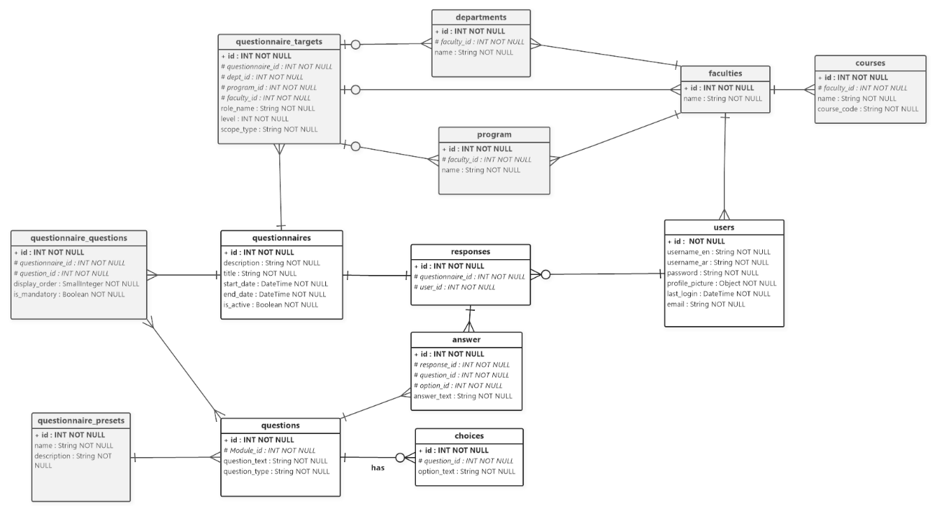

NMU Questionnaire System’s Entity Relationship Diagram

## Class Diagram

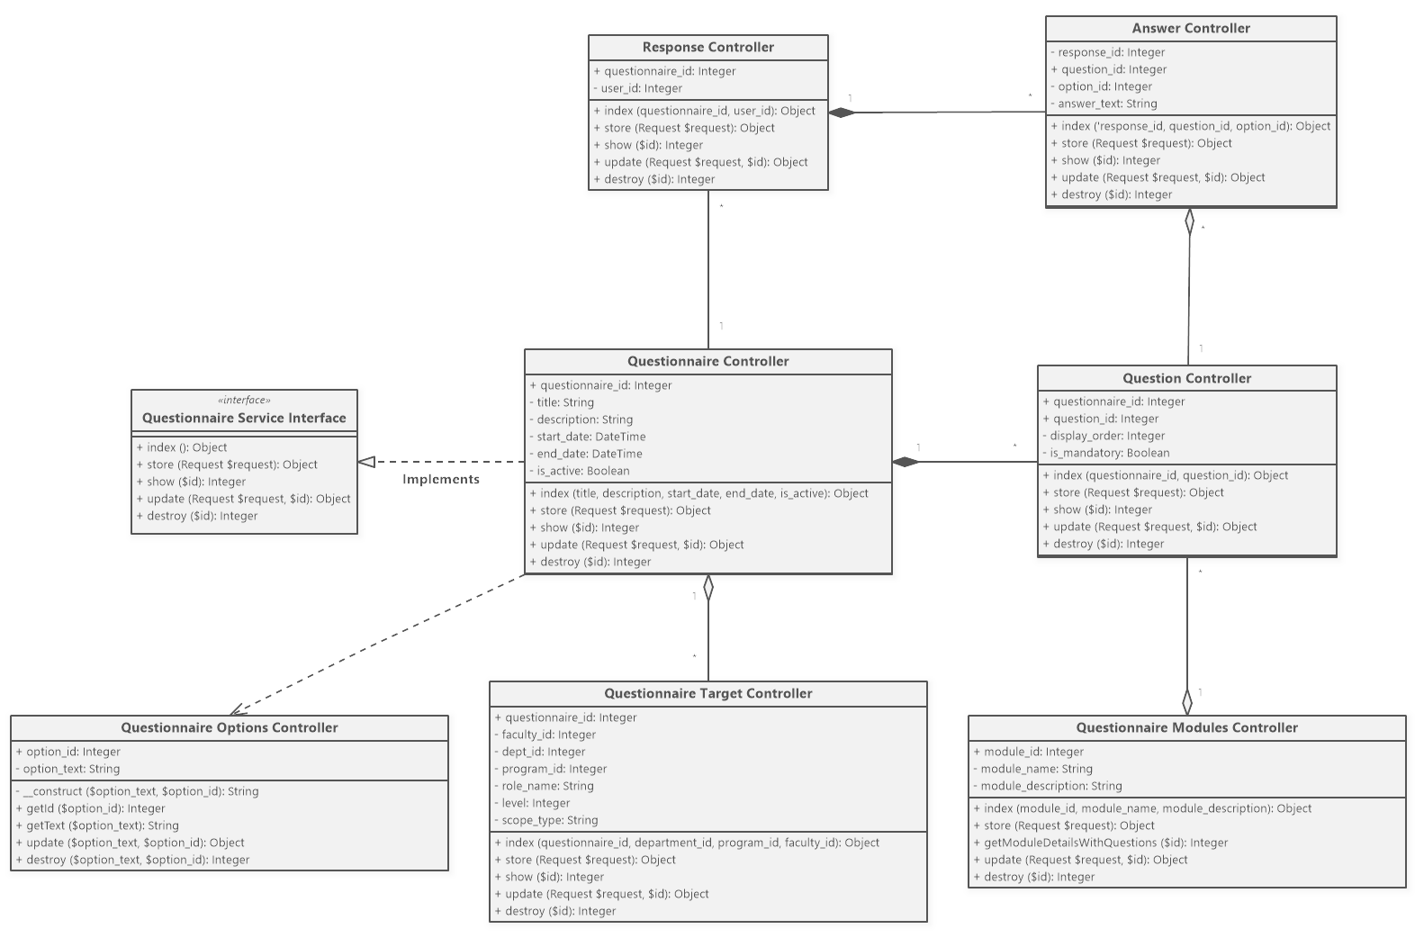

NMU Questionnaire System’s Class Diagram